Sanjivani College of Engineering, Kopargaon

(An Autonomous Institute)

Department of Computer Engineering

CERTIFICATE

This is to certify that

Name: Suyog Sham Chaudhari

Class: B.Tech – Comp-A

Exam Seat no: UCS20M1030

Has successfully completed his/her Internship on

“Future Skills Training in AI (Artificial Intelligence) along with Python, Aptitude and Personality Development Training”

Towards the partial fulfilment of B. Tech. (Computer Engineering) during the academic year 2023-2024

Prof. P.Dhanwate Dr. D.B. Kshirsagar

**Mentor/Coordinator HOD [Comp Dept]**

Certificate of Originality

This is to certify that the Internship report entitled “Future Skills Training in Al (Artificial Intelligence) along with Python, Aptitude and Personality Development Training”

submitted to Savitribai Phule Pune University, Pune in partial fulfilment of the requirements for the award of the degree for B. Tech (Computer Engineering) is an authentic and original work / course completed by Mr Suyog Sham Chaudhari with Seat no UCS20M1030 under Prof.P. Dhanwate guidance at Sanjivani College of Engineering Kopargaon

The matter embodied in the report is the genuine work/course completed by the student and not copied or stolen from anywhere else.

Date:

Signature of Student : Signature of Mentor :

Name of Student: Suyog Chaudhari Name of Mentor: Prof.P.Dhanwate

Mobile no: 9172906892 Mobile no: 8530215898

Email id: chaudharisuyog07@gmail.com Email id: dhanwatepriyanka0506@gmail.com

The internship work presentation of Mr. Suyog Chaudhari is conducted on 12-March-2024

Sign of Internal Examiner Sign of External Examiner

Name: Name:

**Content**

1. **Introduction** –

**Title of the internship:** Future Skills Training in Al (Artificial Intelligence) along with Python, Aptitude and Personality Development Training

**Duration:** 2 Feb 2024 to 16 March 2024

I am thrilled to share my experience and accomplishments following the successful completion of my internship and also very thankful to FUEL CEO Mr. Ketan Deshpande sir who give me opportunity for Future Skills Training in AI (Artificial Intelligence), along with Python, Aptitude, and Personality Development Training at FUEL Business School in Pune. This transformative journey, spanning from February 2, 2024, to March 16, 2024, has equipped me with invaluable skills and experiences that have significantly enriched my professional growth and prepared me for the challenges of the dynamic world of technology and business.

Throughout my internship, I dived deep into the realms of Artificial Intelligence, honing my expertise in cutting-edge technologies and innovative methodologies. Under the guidance of industry experts and mentors, I gained practical insights into AI algorithms, machine learning models, and data analysis techniques, enabling me to tackle real-world problems with confidence and efficiency.

Moreover, my training in Python, a versatile and powerful programming language, provided me with the essential tools to develop robust AI applications, automate tasks, and analyse data effectively.

In addition to technical skills, my internship journey at Future Skills Training and FUEL Business School also emphasized the significance of holistic development. The aptitude training sessions equipped me with critical thinking skills, logical reasoning abilities, a strategic decision-making techniques, essential for navigating complex business landscapes and solving intricate problems.

1. **Objectives:**

**1)** **Mastering Artificial Intelligence (AI) Fundamentals:** One of the primary objectives of my internship was to gain a comprehensive understanding of AI principles, methodologies, and applications. Through hands-on projects, workshops, and lectures, I aimed to deepen my knowledge of AI algorithms, machine learning techniques, and neural networks.

**2) Enhancing Proficiency in Python:** Python serves as a cornerstone for AI development and data science. Therefore, a key objective of my internship was to strengthen my proficiency in Python programming. By engaging in coding exercises, projects, and collaborative tasks, I sought to sharpen my Python skills and become adept at leveraging its capabilities for AI and data analysis.

**3) Developing Aptitude Skills:** Aptitude plays a crucial role in problem-solving and decision-making, especially in the realm of technology and business. I aimed to enhance my aptitude skills through rigorous practice, logical reasoning exercises, and simulated scenarios. By mastering aptitude, I aimed to develop a strategic mindset and analytical prowess essential for tackling complex challenges.

**4) Fostering Personal Growth:** Personal development is integral to professional success. Throughout my internship, I set out to cultivate essential soft skills, including communication, teamwork, and leadership. Through workshops, role-playing activities, and self-reflection exercises, I aimed to nurture a confident and adaptable persona conducive to effective collaboration and leadership.

**5) Applying Knowledge in Real-World Scenarios:** Theory is indispensable, but its true value lies in its practical application. I sought opportunities to apply theoretical concepts and technical skills to real-world problems and projects. By working on industry-relevant assignments and case studies, I aimed to bridge the gap between theory and practice, preparing myself for the challenges of the professional landscape.

**6) Seeking Mentorship and Guidance:** Mentorship is invaluable in guiding professional growth and development. I actively sought mentorship from industry experts, professors, and senior professionals throughout my internship. By leveraging their insights, feedback, and

guidance, I aimed to accelerate my learning, gain perspective, and navigate the intricacies of the field with confidence.

1. **Significance & the Importance:**

For a final year B.Tech computer student, an internship like the one I completed on the topic Future Skills Training in AI, along with Python, Aptitude, and Personality Development Training at FUEL Business School in Pune, holds immense significance and importance. It helps me to get :

**1) Hands-on Experience:** The internship provides an opportunity to apply theoretical knowledge gained throughout the academic curriculum to real-world scenarios. This hands-on experience is invaluable, as it enhances understanding, reinforces learning, and bridges the gap between theory and practice.

**2) Skill Development:** The internship equips students with practical skills that are highly relevant and sought-after in the industry. From technical skills such as AI, Python programming, and data analysis to soft skills like communication, teamwork, and leadership, the internship offers a comprehensive platform for skill development and enhancement.

**3) Industry Exposure:** Engaging in an internship exposes students to the workings of the industry, its dynamics, trends, and challenges. This exposure is crucial for gaining insights into the professional landscape, understanding industry expectations, and aligning academic pursuits with industry requirements.

**4) Networking Opportunities:** The internship provides opportunities for networking with professionals, mentors, and peers within the industry. Building and nurturing professional connections during the internship can open doors to future career opportunities, collaborations, and mentorship.

**5) Resume Enhancement:** Completing an internship adds significant value to the resume of a final year B.Tech computer student. It demonstrates practical experience, skills, and achievements, making the candidate more attractive to potential employers and enhancing employability prospects post-graduation.

**6) Career Exploration:** The internship serves as a platform for exploring career interests, preferences, and aspirations. By working in diverse roles, projects, and environments, students can gain clarity regarding their career goals and make informed decisions about their professional trajectory.

1. **Internship Details :**

During my internship at Future Skills Training in AI, along with Python, Aptitude, and Personality Development Training at FUEL Business School in Pune, I had the privilege of engaging in a diverse range of experiences that enriched my learning and professional growth. Among the many facets of this internship, one significant aspect was working on LinkedIn tracking and delving into the case stories of various companies. Additionally, I had the remarkable opportunity to interact with esteemed professionals, including CEOs and managers from renowned companies such as HSBC, Japanii company Fujitsu, and Capgemini. Furthermore, as a part of the internship requirements, I completed a total of 40 LinkedIn certifications, which further enhanced my skills and expertise in various domains.

**LinkedIn Tracking and Company Case Studies:**

As part of the internship, I have tasked with utilizing LinkedIn tracking tools to analyze trends, patterns, and insights within the professional networking platform. This involved tracking industry-specific keywords, job postings, and networking activities to gain a deeper understanding of the evolving landscape in AI, technology, and business.

In addition to LinkedIn tracking, I had the opportunity to explore case stories of various companies, dissecting their strategies, successes, and challenges. This hands-on approach allowed me to gain practical insights into real-world business scenarios, enhancing my problem-solving abilities and strategic thinking skills.

**Interactions with Industry Leaders:**

One of the highlights of my internship was the chance to interact with CEOs and managers from prominent organizations. These interactions provided invaluable opportunities to gain industry perspectives, learn from seasoned professionals, and build meaningful connections. Engaging in discussions with leaders from HSBC, Japani Company Fujitsu, and Capgemini offered me unique insights into their respective industries, cultures, and strategic priorities.

**Completion of LinkedIn Certifications:**

To further augment my professional skills and credentials, I dedicated myself to completing a total of 40 LinkedIn certifications as part of the internship requirements. These certifications covered a wide range of topics, including AI, data analysis, Python programming, leadership, and digital marketing. By successfully completing these certifications, I not only expanded my knowledge base but also validated my proficiency in key areas essential for success in the modern workplace.

Overall, my internship experience was a transformative journey that equipped me with practical skills, industry insights, and valuable connections. Working on LinkedIn tracking, analyzing company case studies, interacting with industry leaders, and completing LinkedIn certifications were pivotal aspects of this journey, shaping me into a more competent and well-rounded professional poised to make meaningful contributions in the field of technology and business.

**Completed AMCAT Test as a part of evaluation :**

As part of the evaluation criteria for the internship, I underwent the AMCAT (Aspiring Minds Computer Adaptive Test) certification test to assess and apply the technical knowledge acquired during the internship period. The AMCAT test served as a comprehensive evaluation tool to gauge my proficiency in various technical domains and validate my readiness for professional roles in the technology sector. I have also score good marks in this test.

1. **Technologies Learned during internship :**

**1) Artificial Intelligence (AI):** Diving into the realm of Artificial Intelligence, I gained insights into AI principles, methodologies, and applications. This included understanding AI algorithms, machine learning models, natural language processing (NLP), computer vision, and deep learning techniques. Practical projects and workshops enabled me to explore the practical applications of AI in diverse domains such as healthcare, finance, and automation.

**2) Python Programming:** Python emerged as a fundamental tool in my journey, serving as the primary programming language for AI development and data analysis. Through hands-on coding exercises, projects, and collaborative tasks, I honed my skills in Python programming, mastering essential libraries and frameworks such as NumPy, Pandas, TensorFlow, and scikit-learn. Python's versatility and simplicity empowered me to develop robust AI applications, automate tasks, and analyze data efficiently.

**3) Data Analysis and Visualization:** In tandem with Python programming, I delved into the realm of data analysis and visualization. Leveraging libraries such as Pandas, Matplotlib, and Seaborn, I learned to manipulate and analyze datasets, extract meaningful insights, and present findings through compelling visualizations. This proficiency in data analysis equipped me with the ability to derive actionable insights from complex datasets, facilitating informed decision-making.

**4) Aptitude Skills:** Aptitude skills form the foundation of logical reasoning and problem-solving, essential for success in technology and business domains. Through rigorous practice and simulated scenarios, I developed proficiency in quantitative aptitude, logical reasoning, and analytical thinking. This enabled me to approach challenges systematically, devise effective solutions, and make informed decisions.

**5) Personality Development:** Complementing technical skills, I focused on enhancing my soft skills and interpersonal competencies through Personality Development Training. This encompassed communication skills, teamwork, leadership, time management, and emotional intelligence. Role-playing activities, workshops, and self-reflection exercises facilitated my personal growth and professional development, fostering a well-rounded persona conducive to success in diverse environments.

1. **Applications:**

**1) AI Solutions Development:**

Utilizing AI algorithms and Python programming, develop innovative AI solutions for industries such as healthcare, finance, retail, and manufacturing.

Apply AI techniques to automate processes, enhance decision-making, and optimize operations, leading to increased efficiency and productivity.

**2) Data Analysis and Insights:**

Leverage Python's data analysis libraries to analyze vast datasets, extract meaningful insights, and drive informed decision-making for businesses.

Apply AI techniques such as machine learning and natural language processing to uncover patterns, trends, and correlations in data, enabling predictive analytics and actionable insights.

**3) LinkedIn Learning Integration:**

Utilize LinkedIn Learning as a platform to continue learning and upskilling beyond the internship period.

Leverage LinkedIn Learning resources to deepen knowledge in AI, Python programming, leadership skills, and other relevant areas, staying updated with the latest industry trends and best practices.

**4) Industry Networking and Collaboration:**

Forge connections with industry professionals through LinkedIn, leveraging networking opportunities to explore potential collaborations, mentorship, or career opportunities.

Engage with industry leaders and experts to gain insights into emerging technologies, market trends, and industry challenges, fostering continuous learning and professional growth.

**5) Innovative Projects and Research:**

Apply AI and Python skills to initiate and execute innovative projects, addressing real-world challenges and exploring new opportunities for technological advancement.

Collaborate with peers and mentors to conduct research in AI-related fields, contributing to the advancement of knowledge and the development of practical solutions to complex problems.

**6) Entrepreneurial Endeavors:**

Harness AI, Python, and LinkedIn learning to develop entrepreneurial ventures, such as AI-powered startups or consulting services.

Apply aptitude and personality development skills to pitch ideas, build teams, and lead initiatives, transforming innovative concepts into successful business ventures.

**7) Personal and Professional Development:**

Apply aptitude and personality development training to enhance communication skills, teamwork, leadership, and time management abilities.

Utilize acquired skills to navigate career opportunities, present oneself effectively in interviews, and excel in professional roles, fostering personal and professional growth.

1. **Conclusion:**

My internship experience at Future Skills Training in AI, coupled with Python, Aptitude, and Personality Development Training at FUEL Business School in Pune, has been nothing short of transformative. Throughout this journey, I have gained invaluable skills, insights, and experiences that have equipped me for success in the dynamic fields of technology and business.

I am immensely grateful to the CEO of FUEL Business School for granting me this opportunity to embark on this enriching journey. Their vision and commitment to nurturing talent and fostering excellence have been instrumental in shaping my internship experience. Their support, guidance, and mentorship have been invaluable, empowering me to explore my potential and strive for excellence. As I reflect on the culmination of this internship, I am filled with a sense of gratitude, accomplishment, and optimism for the future. I am confident that the skills and experiences gained during this internship will serve as a strong foundation for my future endeavors, enabling me to make meaningful contributions to the industry and society at large.

Once again, I extend my heartfelt thanks to the CEO of FUEL Business School for their unwavering support and for providing me with the opportunity to grow and excel. I look forward to applying the knowledge and skills acquired during this internship to make a positive impact in the world.

1. **References:**

**1) MR. Ketan Deshpande**

[Founder Chairman of FUEL Business School & CEO FUEL Ashoka Fellow, Pavate Follow (JS) University of Cambridge, UK]

Email : ketanfuelgroup@gmail.com

**2) FUEL Business School Address**

FUEL, Township, Paranjape Schemes, Matalwadi Road, A4, Forest Trails, near Manas Lake, Bhugaon, Pune, Maharashtra 412115

Email : admissions@fuelbschool.com

**3) Trainer Name –** Nilesh Somkule

AI with Python Course Trainer

**Annexure A**

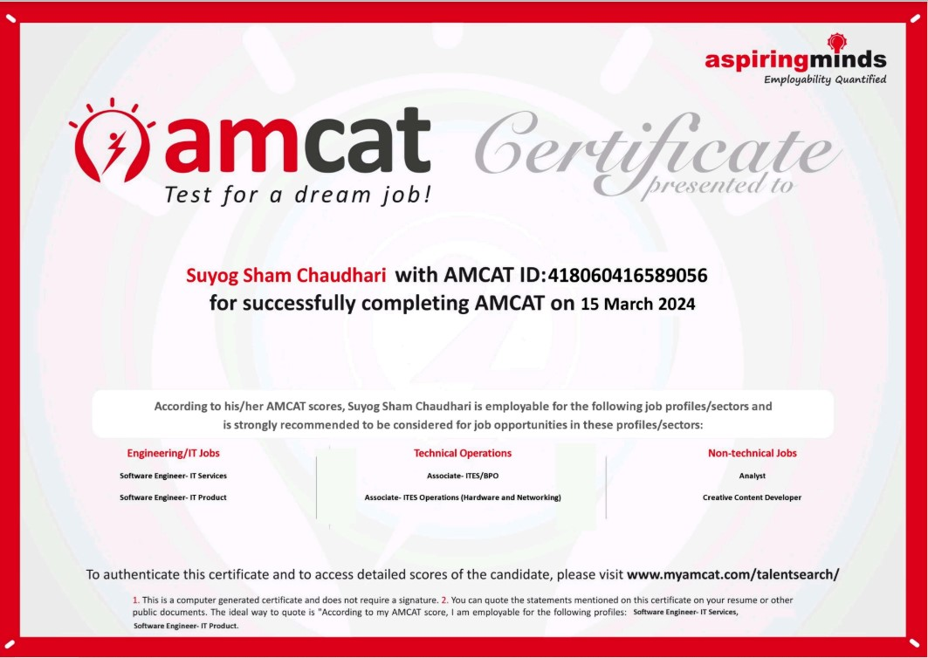

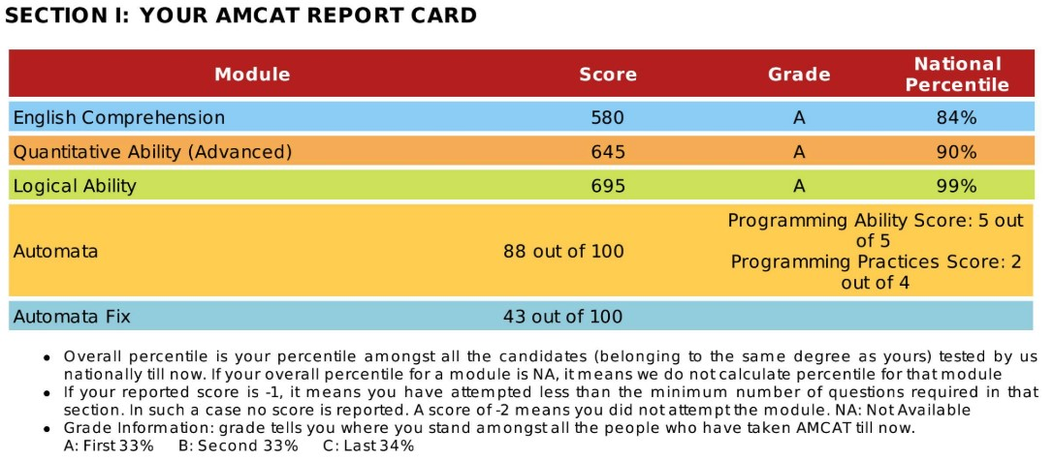

**Annexure B**

**Internship Completion Certificates:**

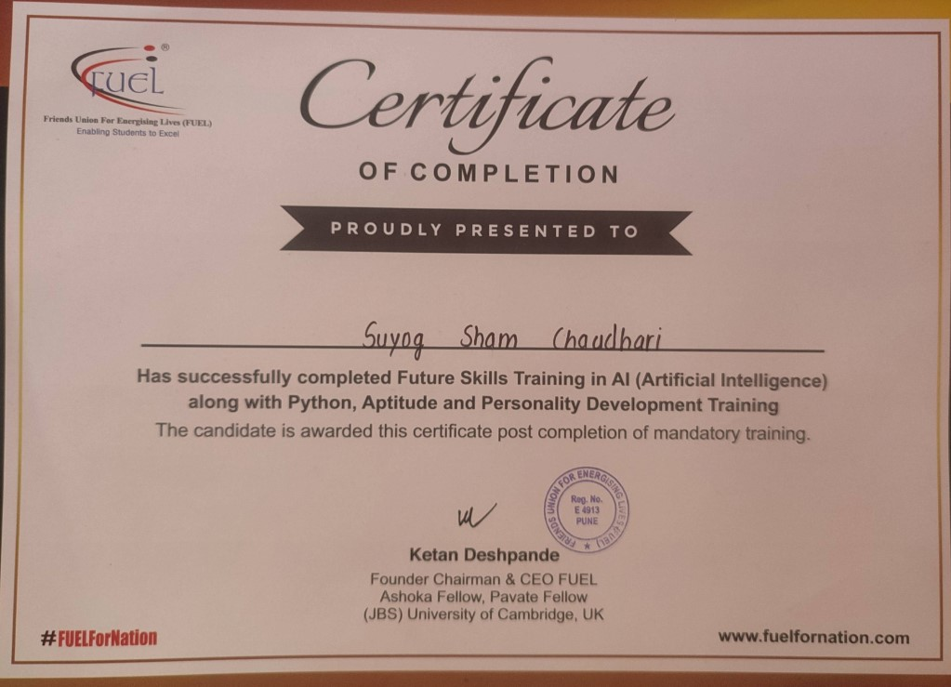

|  |
| --- |
| **Sanjivani College of Engineering, Kopargaon** |
| **Department of Computer Engineering** |
| **Weekly Progress Report** |
| **Professional Internship** |
| **Academic Year 2023-2024 Name: Suyog Sham Chaudhari**  PRN : UCS20M1008 |

|  |  |  |  |
| --- | --- | --- | --- |
| **Week No: 1 to 7** | | **Date**  **02/02/2024**  **to**  **18/03/2024** | |
| **Days** | **Time** | **Activity** | **Work Done** |
| 1. | 10 AM to  7 PM | Introduction to AI | LinkedIn Tracking(Data Analysis and correction, profile data Extraction, Linkdin placement tracking, Profile photo Extarction and validation, profile link verification, Amcat Certicificate  collection and verification) |
| 2. | 10 AM to  7 PM | Introduction to AI | LinkedIn Tracking (Data Analysis and correction, profile data Extraction, Linkdin placement tracking, Profile photo Extarction and validation, profile link verification, Amcat  Certicificate collection and verification) |
| 3. | 10 AM to  7 PM | ML with Python Foundation | LinkedIn Tracking(Data Analysis and correction, profile data Extraction, Linkdin placement tracking, Profile photo Extarction and validation, profile link  verification, Amcat Certicificate collection and verification) |
| 4. | 10 AM to  7 PM | ML with Python Foundation | LinkedIn Tracking(Data Analysis and correction, profile data Extraction, Linkdin placement tracking, Profile photo Extarction and validation, profile link  verification, Amcat Certicificate collection and verification) |
| 5. | 10 AM to  7 PM | **FUEL Conclave (Interaction with Industrial Experts)** | **Event Co-Ordinator(**Manage  the session of various T&p Coordinators and CEO) |
| 6. | 10 AM to  7 PM | Supervised Learning Essential Training | LinkedIn Tracking(Data Analysis and correction, profile data Extraction, Linkdin placement  tracking, Profile photo Extarction and validation, profile link |

|  |  |  |  |
| --- | --- | --- | --- |
|  |  |  | verification, Amcat Certicificate collection and verification) |
| 7. | 10 AM to  7 PM | Supervised Learning Essential Training | LinkedIn Tracking(Data Analysis and correction, profile data Extraction, Linkdin placement tracking, Profile photo Extarction and validation, profile link verification, Amcat Certicificate  collection and verification) |
| 8. | 10 AM to  7 PM | Reinforcement Learning Foundation **(Interaction with Industry Experts of FUJITSU on**  **Communication Skills)** | LinkedIn Tracking(Data Analysis and correction, profile data Extraction, Linkdin placement tracking, Profile photo Extarction and validation, profile link verification, Amcat Certicificate  collection and verification) |
| 9. | 10 AM to  7 PM | Reinforcement Learning Foundation | Gathering information on opportunities in Japanese  Language |
| 10. | 10 AM to  7 PM | Holiday |  |
| a. | 10 AM to  7 PM | Introduction to Python | Fuel Organization Placement informative by calling students |
| 11. | 10 AM to  7 PM | Python Basics (Identifiers,  Keywords and Indentation) | LinkedIn Tracking (Data Analysis and correction, profile data Extraction, Linkdin placement tracking, Profile photo Extarction and validation, profile link verification, Amcat Certicificate collection and  verification) |
| 12. | 10 AM to  7 PM | Python Data Types | Fuel Organization Placement informative by calling students |
| 13. | 10 AM to  7 PM | Python Functions | LinkedIn Tracking(Data Analysis and correction, profile data Extraction, Linkdin placement tracking, Profile photo Extarction and validation, profile link verification, Amcat Certicificate  collection and verification) |
| 14. | 10 AM to  7 PM | Control Flow | LinkedIn Tracking(Data Analysis and correction, profile data Extraction, Linkdin placement tracking, Profile photo Extarction and validation, profile link verification, Amcat Certicificate  collection and verification) |

|  |  |  |  |
| --- | --- | --- | --- |
| 16. | 10 AM to  7 PM | Leave |  |
| 17. | 10 AM to  7 PM | Exception Handling in Python | LinkedIn Tracking(Data Analysis and correction, profile data Extraction, Linkdin placement tracking, Profile photo Extarction and validation, profile link verification, Amcat Certicificate  collection and verification) |
| 18. | 10 AM to  7 PM | Exception Handling in  Python | Fuel Organization Placement  informative by calling students |
| 19. | 10 AM to  7 PM | Database | Fuel Organization Placement informative by calling students |
| 20. | 10 AM to  7 PM | Reinforcement Learning Foundation **(Interaction with Industry Experts of FUJITSU on**  **Communication Skills)** | Gathering information on opportunities in Japanese  Language |
| 21. | 10 AM to  7 PM | Regular Expression | LinkedIn Tracking And Case  Stories |
| 22. | 10 AM to  7 PM | Introduction to Numpy | LinkedIn Tracking |
| 23. | 10 AM to  7 PM | Introduction to Pandas (Time 10 am to 2 pm).  Expert Session on  Healthcare | LinkedIn Tracking (Co – ordinate the event with FUEL photography team) |
| 24. | 10 AM to  7 PM | Type of AI | LinkedIn Tracking(Data Analysis and correction, profile data Extraction, Linkdin placement tracking, Profile photo Extarction and validation, profile link verification, Amcat Certicificate  collection and verification) |
| 25. | 10 AM to  7 PM | Introduction to ML (Time 10 am to 2 pm) Expert Session on Japanese Language | LinkedIn Tracking(Data Analysis and correction, profile data Extraction, Linkdin placement tracking, Profile photo Extarction and validation, profile link verification, Amcat Certicificate  collection and verification) |
| 26. | 10 AM to  7 PM | Supervised Learning (Models) | LinkedIn Tracking(Data Analysis and correction, profile data Extraction, Linkdin placement tracking, Profile photo Extarction and validation, profile link verification, Amcat Certicificate  collection and verification) |

|  |  |  |  |
| --- | --- | --- | --- |
| 27. | 10 AM to  7 PM | Regression Model | LinkedIn Tracking(Data Analysis and correction, profile data Extraction, Linkdin placement tracking, Profile photo Extarction and validation, profile link verification, Amcat Certicificate  collection and verification) |
| 28. | 10 AM to  7 PM | Source Vector Machine | Case Stories(building case story of various Successful  personalitys) |
| 29. | 10 AM to  7 PM | Machine Learning Concept | Case Stories(building case story of various Successful  personalitys) |
| 30. | 10 AM to  7 PM | Technical Coding  Preparation | Linkedin Tracking & Case Stories |
| 31. | 10 AM to  7 PM | Technical Coding Preparation | Case Stories(building case story of various Successful  personalitys) |
| 32. | 10 AM to  7 PM | Revision of Leraned Concept | Linkedin Tracking(Data Analysis and correction, profile data Extraction, Linkdin placement tracking, Profile photo Extarction and validation, profile link verification, Amcat Certicificate  collection and verification) |
| 33. | 10 AM to  7 PM | Completion of Linkedin  Certtification provided by FUEL | Case Stories(building case story of various Successful personalitys) |
| 34. | 10 AM to  7 PM | Yes Bank Session on Financial Literacy | Linkedin Tracking(Data Analysis and correction, profile data Extraction, Linkdin placement tracking, Profile photo Extarction and validation, profile link  verification, Amcat Certicificate collection and verification) |

|  |  |  |  |
| --- | --- | --- | --- |
| 35. | 10 AM to  7 PM | Yes Bank Session on Financial Literacy | Case Stories(building case story of various Successful personalitys) |
| 36. | 10 AM to  7 PM | Works On Various Dataset Using SQL | Linkedin Tracking(Data Analysis and correction, profile data Extraction, Linkdin placement tracking, Profile photo Extarction and validation, profile link verification, Amcat Certicificate collection and verification) |
| 37. | 10 AM to  7 PM | Database Operation Using SQL | Case Stories(building case story of various Successful personalitys) |

|  |  |  |  |  |  |  |
| --- | --- | --- | --- | --- | --- | --- |
| 38. | | 10 AM to  7 PM | Completion of  Linkedin Certtification provided by FUEL | | Linkedin Tracking(Data Analysis and correction, profile data Extraction, Linkdin placement tracking, Profile photo Extarction and validation, profile link verification, Amcat Certicificate  collection and verification) | |
| 39. | | 10 AM to  7 PM | Revision of Entire Training | | Case Stories(building case story of various Successful personalitys) | |
| 40. | | 10 AM to  7 PM | Expert Session on IGS Language | | Case stories and linkdein tracking | |
|  | 41. | 10 AM  to  7 PM | | Completion of  Linkedin Certtification provided by FUEL | Follow up |  |
|  | 42. | 10 AM  to  7 PM | | Revision of Entire Training | Linkdein tracking(Data Analysis and correction, profile data Extraction, Linkdin placement tracking, Profile photo Extarction and validation, profile link  verification, Amcat Certicificate collection and verification) |  |
|  | 43. | 10 AM  to  7 PM | | Completion of Linkedin Certtification | (building case story of various Successful personalitys) |  |
|  | 44. | 10 AM  to  7 PM | | Technical Coding Preparation | Amcat Test |  |
|  | 45. | 10 AM  to  7 PM | | End of Training and Felicitations Program | End of Training and Felicitation Program |  |



Nilesh Sir Prof. P. Dhanwate

(Trainer in FBS) (Mentor)